***Applied Data Science 1***

***(Statistics and Trends)***

***Name:-Mansi Rakeshkumar Patel***

***Student ID:-21087736***

***Topic for Bar graph:-Percentage of How much Hydroelectric and coal resources were used in the production of Electricity.***

***Topic for line graph:-To represent how much birth rate was there over Total Population worldwide.***

***REPO link***[***:-*** ***https://github.com/Mansipatel2919/ADS-2-resubmission.git***](:-%20%20%20%20https:/github.com/Mansipatel2919/ADS-2-resubmission.git)

***REPORT***

* In this ,statistics and trends, the data is used from worldbank from <https://data.worldbank.org/topic/climate-change>. There are two dataset are used in namely PRODUCTION OF ELECTRICITY FROM HYDROELECTRIC SOURCES and PRODUCTION OF ELECTRICITY FROM COAL RESOURCES. Using this dataset I’ve compare the percentage of how much proportion of hydroelectric and coal used over a period of five years from 1971 to 2000.
* For linegraph, I have compared how much birth rate is there over total population in the worldwide over a decades from 1960 to 2020.
* In first graph:- On x- axis I’ve taken country Name and on Y- axis Years .
* In second graph – I’ve taken years on x-axis and On Y- axis country name.

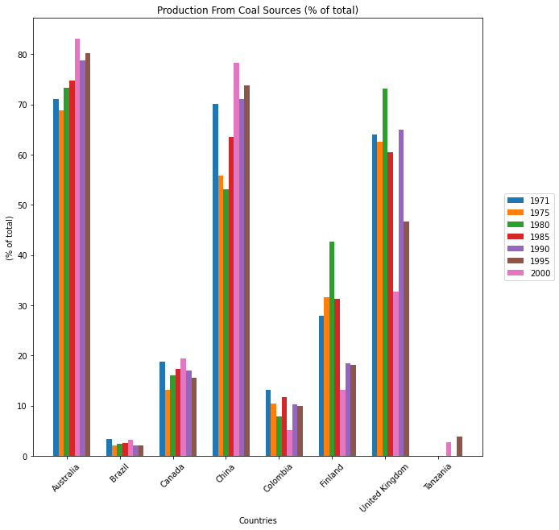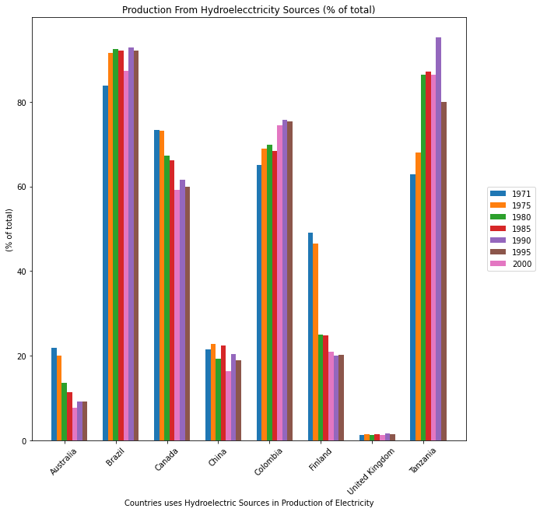

* The bar graph above compares the production of electricity by from Hydroelectricity sources in eight different countries from years 1971 to 2000 in five years increments .At the beginning of the period, in 1971, the production from hydroelectric sources in Australia were above 20%.

Whereas in Brazil they use 80% of the total source. Apart from that, Canada, China, Colombia, Finland used the average hydroelectric sources to produce electricity throughout the given period. Tanzania used the highest amount of hydro sources in 1990 and United Kingdom were at below 20% in the usage of resource for the production.The hydroelectric was more used in the production compared to coal resources.

The “production from hydroelectricity” and “production from coal resources have sideways trends which is significant phenomenon.

To sum up, it can be seen that, in the production of electricity, hydroelectric sources are more used compared to coal resources from the above mentioned countries.

.

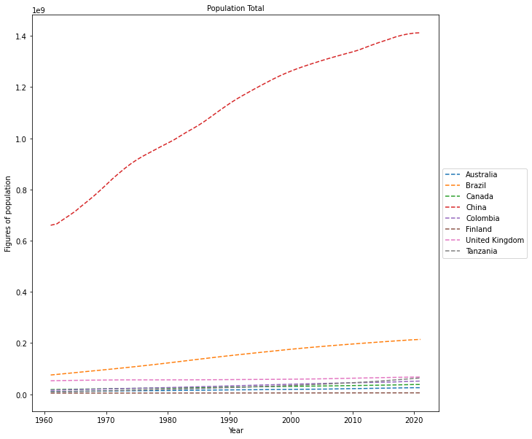

The line graphs compares total population of the Australia,Brazil,Canada,China,Colombia,Finland,,United Kingdom and Tanzania between 1960 to 2020 .Overall, it can be seen that China had highest population. Whereas, the other mentioned countries had least population.

In 1960 , china had highest population which was 667070000 and it reached at peak in 2020(1411100000). Second highest populated country was brazil and peaked at (213196304) in 2020.

In sharp contrast, Australia,Canada,Tanzania, And finland were the least populated countries Showed an average population around (5529543) in 2020

* Very interesting results can be seen From the above graphical representation it can be clearly seen that population is increasing year by year but birth rate is decreasing per ( 1000) people

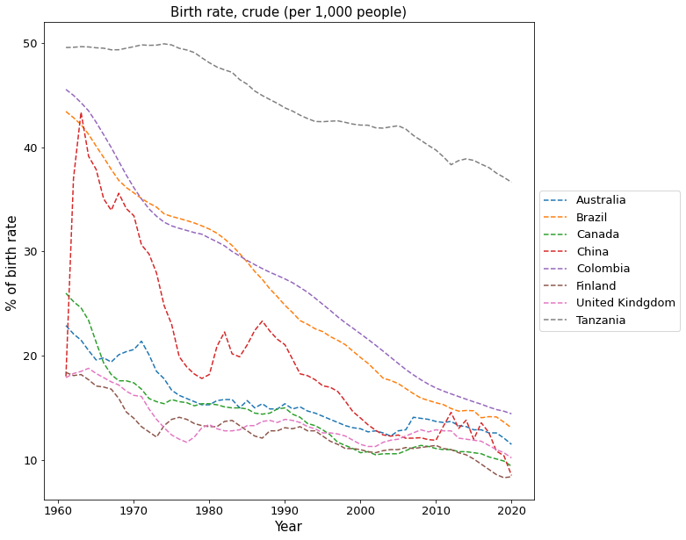

This line graph illustrates the birth rate of plotted countries over a period of decade from 1960 to 2020.Overall, it can be seen that Finland had the higest birth rate in 1960 which is 50% .whereas the least birth was in Tanzania which was around 20%.

In 1960, highest birth rate was in Finland around 50% which fall down to around 38% in 2020. Brazil and Colombia was the second highest birth rate which was between 50% and 40% in 1960 then it showed the downward trend and reached at 15% in 2020.Interestingly , china showed a different trend in the birth rate from 1960 to 1970 it grew from 17% to 42% then it laid down to 15% at the end of period .

In contrast, other remaining countries showed a similar change in birth rate from the given period of time .